Problem Statement :

IoT-Based Smart Crop Protection System for Agriculture

Domain :

Internet of Things

Assignment 4 :
Write code and connections in wokwi for the ultrasonic sensor. Whenever the distance is less than 100 cms send an "alert" to the IBM cloud and display in the device recent events.

By,
A Aathitheya - 913119106001
T Chalene - 913119106018
A D Narmadha - 913119106069
R M Elayavarman - 913119106023

Link :
https://wokwi.com/projects/346930763313185363

Circuit :
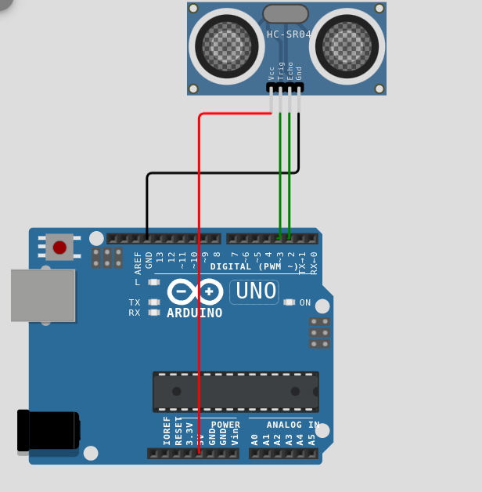

Code :
#define ECHO_PIN 2
#define TRIG_PIN 3

void setup()

{

// put your setup code here, to run once:

Serial.begin(9600);

pinMode(TRIG_PIN, OUTPUT);

pinMode(ECHO_PIN, INPUT);

}

float readDistanceCM(){

digitalWrite(TRIG_PIN , LOW);

delayMicroseconds(2);

digitalWrite(TRIG_PIN, HIGH);

delayMicroseconds(10);

digitalWrite(TRIG_PIN , LOW);

int duration=pulseIn(ECHO_PIN, HIGH);

return duration*0.034 / 2;
}

void loop() {

// put your main code here, to run repeatedly:

float distance=readDistanceCM();

if(distance <= 100)
{
Serial.println("person founded");
}

else
{

Serial.print("Measured distance: ");

Serial.println(readDistanceCM());

}
delay(100);
}

Simulation :

